Project Topic Paper:

A Relationship Between the Size and Intelligence of Dog Breeds

**Intro**

In this project, I will examine a possible link between dog size and intelligence. I have found two datasets to use for this project. The first includes information about the sizes of 150 distinct dog breeds, including a low and high numeric value for dog height, in inches, and weight, in pounds. The second dataset provides information about the intelligence of 136 distinct dog breeds. In this dataset, the breeds are given a categorical value entitled classification. The classification refers to the dogs’ “working/obedience intelligence,” the highest value being “brightest dogs” and the lowest value being “lowest degree of working/obedience intelligence.”

The degree of intelligence for each breed is based upon obedience trials performed by the

American Kennel Club and the Canadian Kennel Club per the request of Stanley Coren, a

“professor of canine psychology at the University of British Columbia”(2) for his book The Intelligence of Dogs. In these evaluations, the dogs were taught a new command. The low and high number of repetitions it took for dogs of a certain breed to understand a new command, and the probability that they would obey the first command are provided in the dataset as reps_lower, reps_upper, and obey, respectively. As an example of how these values are used to classify dogs, a breed falls into the “Brightest Dogs” category if dogs have a reps_upper value less than or equal to 5, and obey the first command “95% of the time or better” (2). From there, the intelligence rating goes down.

**Midterm Report**

I began organizing my data by combining the breed intelligence and breed size .csv files into one table. Since there are different breeds in each dataset, quite a few rows were missing either size data or intelligence data. Neither of these would be useful for gathering information, so I eliminated the rows for which data values were missing for any column.

I made a plot by taking the values from the height and weight columns for all of the breeds and storing them into arrays using NumPy.

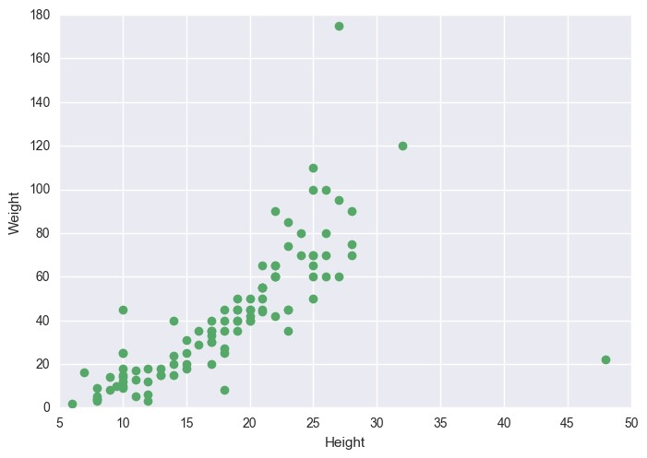

Next, I used the same plots, except colored each of the points based on their

classification.

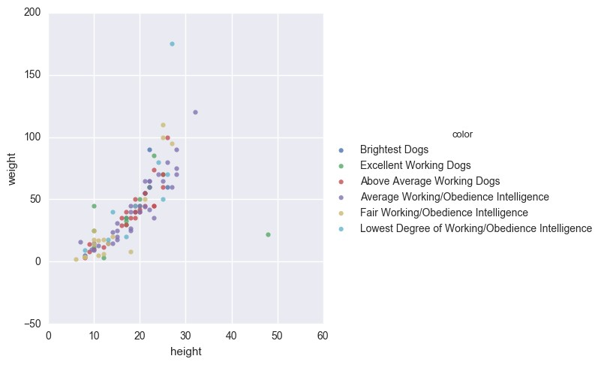

Just by looking at this graph, it is hard to tell whether there will be a relationship between breed size and intelligence. There are many data points of each color spread across the plot, so I must find another way to group the breeds. My first thought was taking a closer look at the build of the dogs, possibly shorter, heavier dogs might be more or less intelligent than shorter, lighter dogs. Moving forward, I’d like to analyze the breed sizes so that I could find a way to categorize the breed sizes, rather than just using the numeric values.

**Project Topic Paper Update**

Moving forward, I began to rearrange the data so that it would be easier to analyze. I took the average of the high and low heights and weights for each breed and put those into an average height and average weight column. I also assigned each intelligence classification a numeric value (1 being the least intelligent group and 6 being the most intelligent). I categorized the dogs based on size as well, grouping them by their weights. I chose rather than height to begin with, because that is how I have most often seen dog size referenced as. However, I could do the same for height and see if this yields similar results. The data set that I am working with now looks like the following:

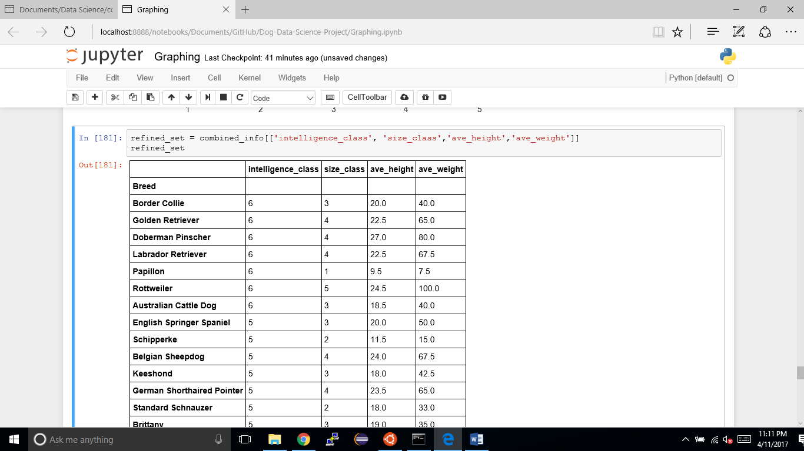

After finding the average heights and weights, I found a BMI formula, which is used on humans, but I tried applying it to dogs here.

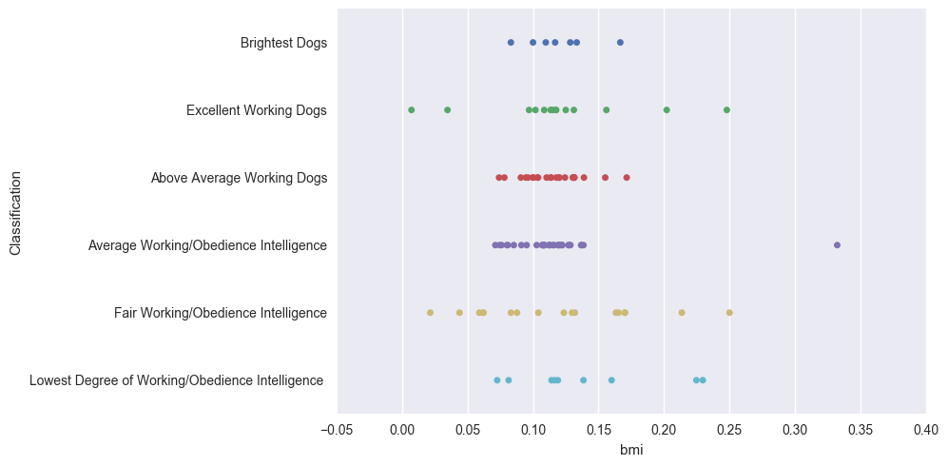

Since most dogs seemed to have a similar range of BMIs, regardless of intelligence, it was difficult to draw any conclusions from this data. It can be observed that dogs of average and slightly above average intelligence have a much smaller range of BMIs than the dogs with intelligences on the extreme ends of the spectrum. Also, the dogs that were ranked either excellent or fair had the largest ranges of BMIs. Unfortunately, these observations are not likely to lead to any conclusions about a definitive link between size and intelligence.

Moving forward, I calculated the mean and median intelligence class for each classification of size. Here, I plotted the average and median intelligences for each class, the green representing the median and the blue representing the average.

Size Class

Intelligence Class

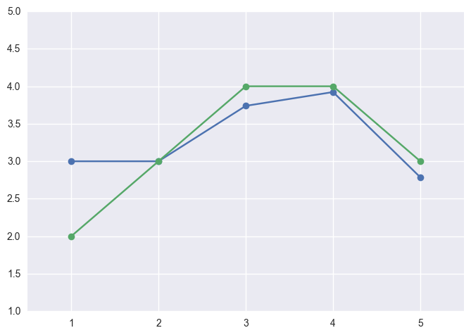

One can observe that medium sized and large sized dogs seem to have the highest intelligence ratings. This might be something that I will begin to examine further.

References

1. Fishman, L. Is there are relationship between dog size and dog intelligence?, *Data.world*. Retrieved March 9, 2017, from Data.World:

[https://data.world/len/dog-size-intelligence-linked.](https://data.world/len/dog-size-intelligence-linked)

1. "The Intelligence of Dogs", *En.m.wikipedia.org*. Retrieved March 9, 2017, from Wikipedia.  [https://en.m.wikipedia.org/wiki/The_Intelligence_of_Dogs#cite_refReferenceA_18-0.](https://en.m.wikipedia.org/wiki/The_Intelligence_of_Dogs#cite_ref-ReferenceA_18-0)

GitHub URL:<https://github.com/0314beilkej/Dog-Data-Science-Project>